Enquiry for Aluminium and Steel Channels and Components

We are looking for the required materials and components as listed below. Engineering drawings have also been attached for some components.

Please provide separate quotes for both Requirement 1 and Requirement 2.

Requirement 1

|  |  |  |  |  |
| --- | --- | --- | --- | --- |
| Item | Cross-section | Length | Quantity | Additional Notes |
| 12 Gauge Aluminium Strut Channel | 41mm x 41mm | 2440mm | 2 | See Image Below |
| 12 Gauge Aluminium Strut Channel | 41mm x 41mm | 2320mm | 2 |  |
| 12 Gauge Aluminium Strut Channel | 41mm x 41mm | 1325mm | 2 |  |
| 12 Gauge Aluminium Strut Channel | 41mm x 41mm | 1025mm | 2 |  |
| 12 Gauge Aluminium Strut Channel | 41mm x 41mm | 745mm | 2 |  |
| 12 Gauge Aluminium Strut Channel | 41mm x 41mm | 1065mm | 2 |  |
| 12 Gauge Aluminium Strut Channel | 41mm x 41mm | 2465mm | 4 |  |
| 12 Gauge Aluminium Strut Channel | 41mm x 41mm | 597mm | 2 |  |
| Steel Roof Mounting Bracket |  |  | 4 | See Engineering Drawing Below |
| Steel Wall Mounting Bracket |  |  | 4 | See Engineering Drawing Below |
| Steel Base Joint Mechanism |  |  | 8 | See Engineering Drawing Below |
| Steel Strut Joint Mechanism - Small |  |  | 12 | See Engineering Drawing Below |
| Steel Strut Joint Mechanism - Large |  |  | 4 | See Engineering Drawing Below |
| Steel Bearing Slider |  |  | 4 | See Engineering Drawing Below |
| 3/8″ Bolts and Washers |  |  | 32 |  |
| 3/8″ Spring Nut |  |  | 20 |  |
| 3/8″ Torsion Spring |  |  | 4 |  |
| 3/8″ Eye Bolts |  |  | 4 |  |

These are the required materials, items and hardware in the required quantities for Requirement 1

Requirement 2

|  |  |  |  |  |
| --- | --- | --- | --- | --- |
| Item | Cross-section | Length | Quantity | Additional Notes |
| 12 Gauge Aluminium Strut Channel | 41mm x 41mm | 2440mm | 10 | See Image Below |
| 12 Gauge Aluminium Strut Channel | 41mm x 41mm | 2320mm | 10 |  |
| 12 Gauge Aluminium Strut Channel | 41mm x 41mm | 1325mm | 10 |  |
| 12 Gauge Aluminium Strut Channel | 41mm x 41mm | 1025mm | 10 |  |
| 12 Gauge Aluminium Strut Channel | 41mm x 41mm | 745mm | 10 |  |
| 12 Gauge Aluminium Strut Channel | 41mm x 41mm | 1065mm | 10 |  |
| 12 Gauge Aluminium Strut Channel | 41mm x 41mm | 2465mm | 20 |  |
| 12 Gauge Aluminium Strut Channel | 41mm x 41mm | 597mm | 10 |  |
| Steel Roof Mounting Bracket |  |  | 20 | See Engineering Drawing Below |
| Steel Wall Mounting Bracket |  |  | 20 | See Engineering Drawing Below |
| Steel Base Joint Mechanism |  |  | 40 | See Engineering Drawing Below |
| Steel Strut Joint Mechanism - Small |  |  | 60 | See Engineering Drawing Below |
| Steel Strut Joint Mechanism - Large |  |  | 20 | See Engineering Drawing Below |
| Bearing Slider |  |  | 20 | See Engineering Drawing Below |
| 3/8″ Bolts and Washers |  |  | 160 |  |
| 3/8″ Spring Nut |  |  | 20 |  |
| 3/8″ Torsion Spring |  |  | 20 |  |
| 3/8″ Eye Bolts |  |  | 20 |  |

These are the required materials, items and hardware in the required quantities for Requirement 2

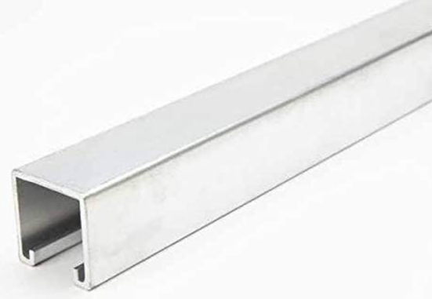

12 Gauge Aluminium Strut Channel

Engineering Drawing of the Roof Mounting Bracket

Engineering Drawing of the Wall Mounting Bracket

Engineering Drawing of the Base Joint Mechanism

b)

a)

Engineering Drawing of the Strut Joint Mechanism; (a) Smaller Component (b) Larger Component

Engineering Drawing of the Bearing Slider